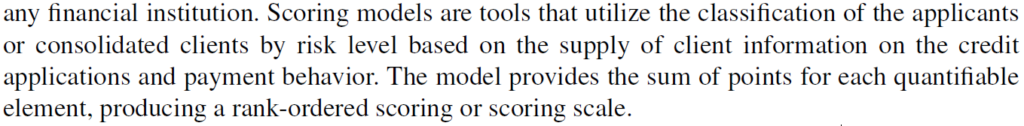

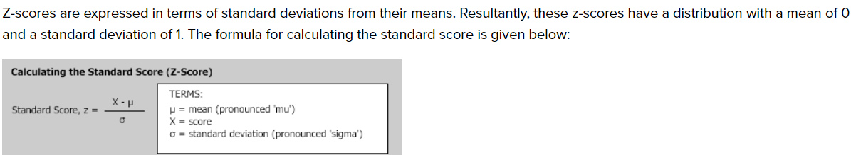



Credit makesit possible to make purchases in advance based on their payment capacity.